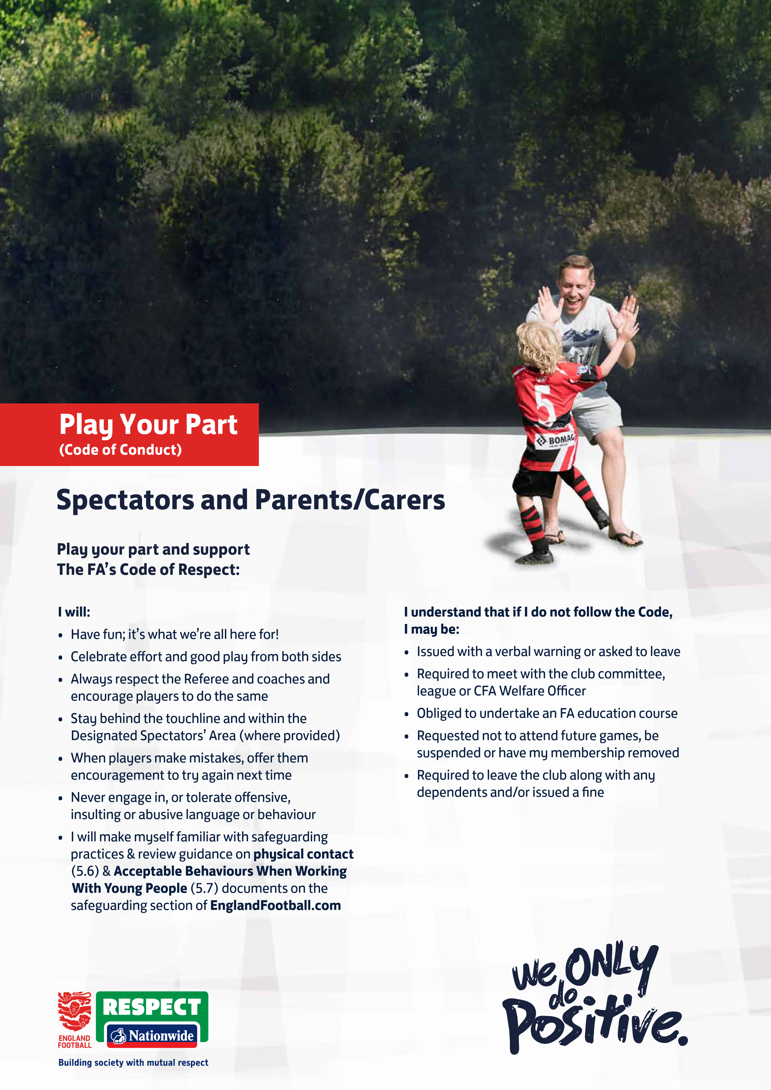

• If I am a Parent/Carer, I will encourage and support my child to follow their Youth Players Code of Conduct, too

**EBBSFLEET UNITED   
WOMEN & YOUTH**

**2024/25 SEASON**

**Signed:  
Name:**