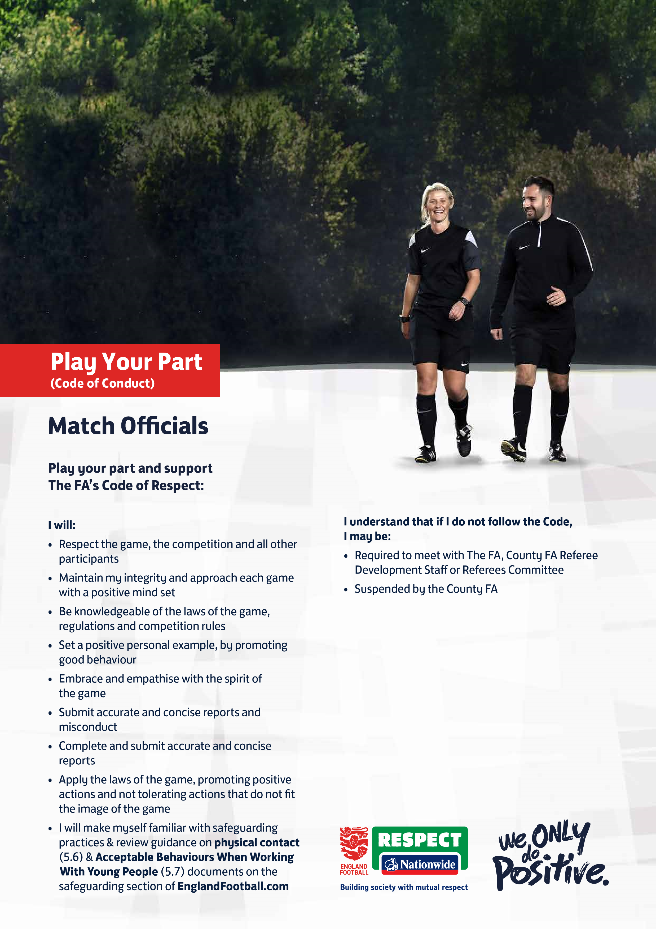

**EBBSFLEET UNITED   
WOMEN & YOUTH**

**2023/24 SEASON**

**Signed:  
Name:**