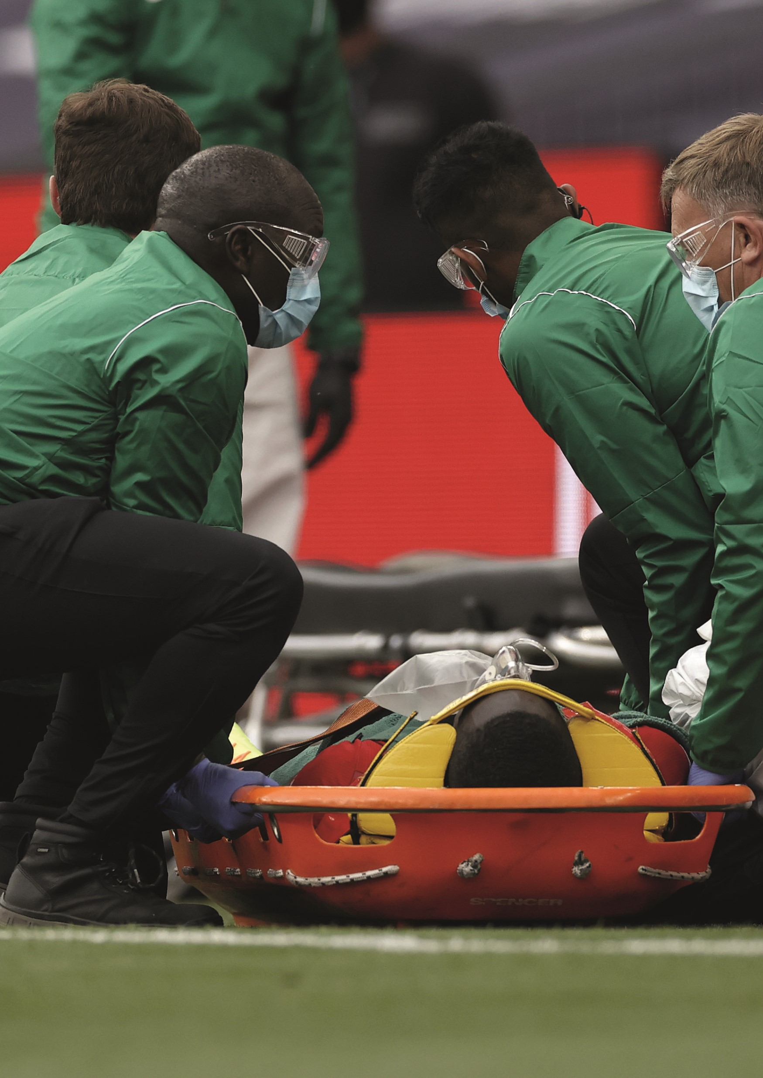
REPORT
ACCIDENT

EBBSFLEET UNITED
WOMEN

If an accident or incident takes place at a venue that you are playing or training at, it must be recorded. This accident form template includes all the information you need to include and keep for future accident reviews and preventions. You can complete this template online.

Please complete all information that is relevant to the situation. If you are reporting an accident or incident that has affected someone under the age of 18 years old, you need to fill out Section 5b of the report. If the incident involves an adult, you should fill out Section 5a instead.

Accident Report Documents will be stored for 3 Years.

Please email the completed form to the Club Safeguarding Officer within 24 hours of the incident. Please email to safeguarding.euwfc@gmail.com

An investigation will then take place.

A Separate Accident Form must be completed for each person who is injured, as a result of the accident/incident.

Section 1: Club Details
Club Name: | Ebbsfleet United Women
Address of company / organisation:
Name of Coach and Team:
Name of Person Reporting Accident and their Official status:
Contact number: |  | Email address:

Section 2: Person Affected by the Accident
Full Name
Age
Team:
Coach’s Name:
Section 2a: Parent / Carer of the Person Affected by the Accident *

Parent/Carer’s Name
Contact Number
Was Parent/Carer Notified? If Yes Please note time.

* Complete only if the Person Affected by the Accident is under 18 years old

`

Section 3: Accident Details
Date of accident: |  | Time of accident:
Location of accident:
Describe the accident:
(e.g. what happened? Why do you think it happened? Was any equipment involved?
Were other people involved? For bodily injuries a body diagram has been included for you to mark the injuries of the casualty)

Full name and address(es) of accident witness(es):

Name: |  | Name |  | Name
Address: |  | Address |  | Address
Section 4: Injury and Treatment Details
Description of injuries sustained:

Was any first aid administered on the premises? | Yes/No | If Yes – What treatment  did they receive and who  administered it?
Did the casualty have to go to hospital immediately? | Yes/No | If Yes, what treatment  did they receive?
Did the casualty have to go to their GP or hospital as a follow up? | Yes/No | If Yes, how long did the  casualty have to spend  in hospital?

Section 5a: Sign-Off
Name of Casualty: |  | Name of Person Completing the accident form:
Job Title: |  | Job Title:
Signature: |  | Signature:

Section 5b: Sign-Off
Name of Casualty: |  | Name of Person Completing the accident form:
Name of Casualty’s  parent/Carer: |  | Job Title:
Parent /Carer Signature: |  | Signature:

